INDEX

CHAPTER 1: INTRODUCTION
  - Introduction of the project……………………………………
  - Project overview
  - Thesis……
CHAPTER 2: HARDWARE DESCRIPTION
2.1 Introduction with block diagram
2.2 Regulated power supply
2.3 MOSFET.
2.4 Mono Stable Multi Vibrator
2.5 DC motor
2.6 POT
2.7 Solar Panel
2.8 Wind turbine
CHAPTER 3: PROJECT DESCRIPTION
CHAPTER 4: ADVANTAGES, DISADVANTAGES AND APPLICATIONS
CHAPTER 5: RESULTS, CONCLUSION, FUTURE PROSPECTS
REFERENCES

CHAPTER 1: INTRODUCTION

  - Introduction:

The project aims at developing a system which makes use of wind and solar energy for rural electrification. Wind and solar energy is treated as non renewable source of energy. The system also uses switch to control the devices.
Wind and solar energy has been used since the earliest civilization to grind grain, pump water from deep wells, and power sailboats. Wind-mills in pre-industrial Europe were used for many things, including irrigation or drainage pumping, grain-grinding, saw-milling of timber, and the processing of other commodities such as spices, cocoa, paints and dyes, and tobacco. Before the U.S. installed an infrastructure of electricity wires, both water-pumping windmills and small wind electric turbines (wind chargers) were vital to farming and developing the American Great Plains and west. In recent decades, the industry has been perfecting the wind turbine to convert the power of the wind into electricity. The wind turbine has many advantages that make it an attractive energy source, especially in parts of the world where the transmission infrastructure is not fully developed. It is modular and can be installed relatively quickly, so it is easy to match electricity supply and demand. The fuel – the wind – is free and plentiful, which eliminates or reduces the need to purchase, ship, and store expensive fuels. It is flexible with the power generated, households use can use appliances, such as lighting and refrigeration, schools can use computers and televisions, and industries can access a reliable power source. Perhaps most importantly, the generator does not produce any harmful emissions in the process of generating the electricity, unlike many other generation sources.
The project makes use of a wind turbine and solar panels. The wind energy obtained is stored to a battery. The battery supply is fed to pulse generator and in turn to a MOSFET which is capable of generating ON/OFF pulses of different frequencies. This is fed to a step up transformer to generate a low voltage AC. This AC is fed to electrical appliance.
1.2 Project Overview:
The project “Hybrid Energy (Wind-Solar) for Rural Electrification” can be done using MOSFET, Mono stable multi vibrator, DC motor, Pot, transformer, Solar panel we can generate voltage with inverter using mechanical energy through hand drive.
1.3 Thesis:
The thesis explains the implementation of “Hybrid Energy (Wind-Solar) for Rural Electrification”. The organization of the thesis is explained here with:

CHAPTER 2: HARDWARE DESCRIPTION

2.1 Introduction:
In this chapter the block diagram of the project and design aspect of independent modules are considered. Block diagram is shown in fig: 2.1: 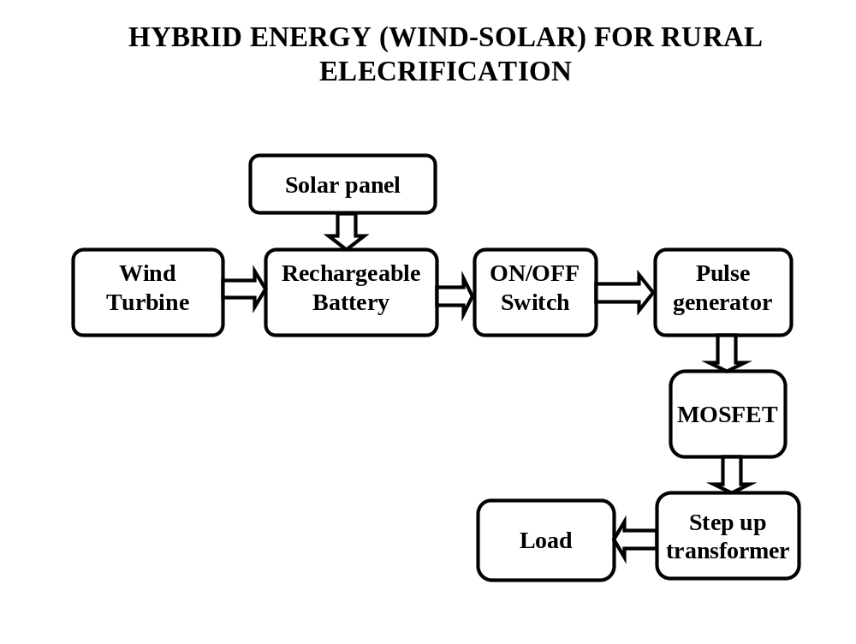
FIG 2.1: Block diagram of Hybrid Energy (Wind-Solar) for Rural Electrification
The main blocks of this project are:
1. Battery power supply (RPS)
2. Geared DC motor
4. Polarity Corrector
5. Mono stable multi vibrator
6. Pot
7. MOSFET
8. Solar panel
9. Wind turbine

2.2 REGULATED POWER SUPPLY:
Block Diagram: 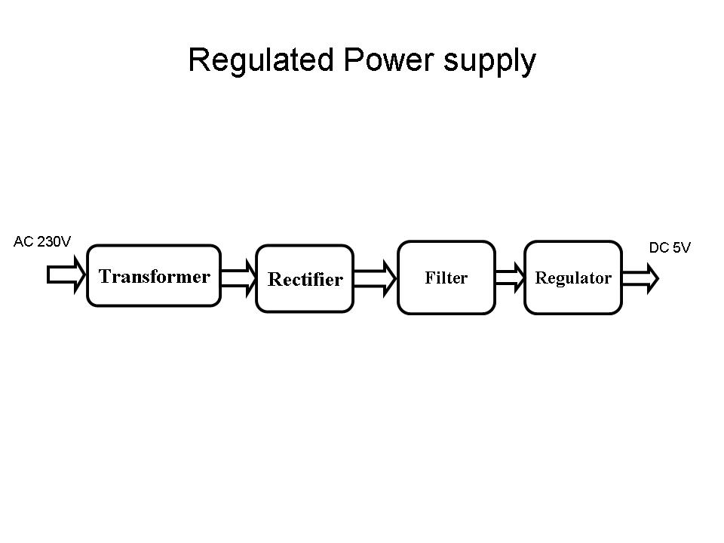
Fig 2.2 Regulated Power Supply
The basic circuit diagram of a regulated power supply (DC O/P) with led connected as load is shown in fig: 2.3
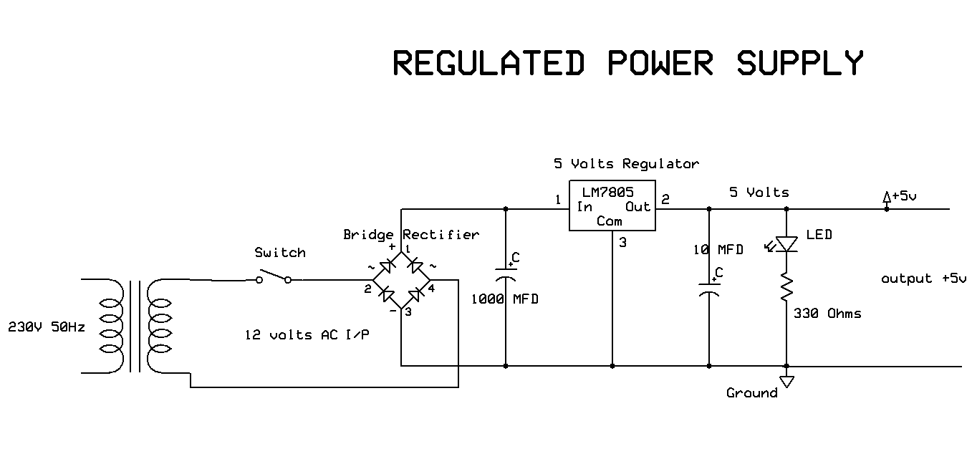
Fig 2.3 Circuit diagram of Regulated Power Supply with LED connection
The components mainly used in above figure are
- 230V AC MAINS
- TRANSFORMER
- BRIDGE RECTIFIER(DIODES)
- CAPACITOR
- VOLTAGE REGULATOR(IC 7805)
- RESISTOR
- LED(LIGHT EMITTING DIODE)

The detailed explanation of each and every component mentioned above is as follows:
Transformation: The process of transforming energy from one device to another is called transformation. For transforming energy we use transformers.
Transformers:
A transformer is a device that transfers electrical energy from one circuit to another through inductively coupled conductors without changing its frequency. A varying current in the first or primary winding creates a varying magnetic flux in the transformer's core, and thus a varying magnetic field through the secondary winding. This varying magnetic field induces a varying electromotive force (EMF) or "voltage" in the secondary winding. This effect is called mutual induction.
If a load is connected to the secondary, an electric current will flow in the secondary winding and electrical energy will be transferred from the primary circuit through the transformer to the load. This field is made up from lines of force and has the same shape as a bar magnet.
If the current is increased, the lines of force move outwards from the coil. If the current is reduced, the lines of force move inwards.
If another coil is placed adjacent to the first coil then, as the field moves out or in, the moving lines of force will "cut" the turns of the second coil. As it does this, a voltage is induced in the second coil. With the 50 Hz AC mains supply, this will happen 50 times a second. This is called MUTUAL INDUCTION and forms the basis of the transformer.
The input coil is called the PRIMARY WINDING; the output coil is the SECONDARY WINDING. Fig: 2.4 shows step-down transformer.
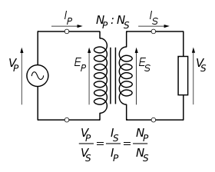
Fig 2.4: Step-Down Transformer
The voltage induced in the secondary is determined by the TURNS RATIO.
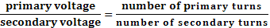
For example, if the secondary has half the primary turns; the secondary will have half the primary voltage.
Another example is if the primary has 5000 turns and the secondary has 500 turns, then the turn’s ratio is 10:1.
If the primary voltage is 240 volts then the secondary voltage will be x 10 smaller = 24 volts. Assuming a perfect transformer, the power provided by the primary must equal the power taken by a load on the secondary. If a 24-watt lamp is connected across a 24 volt secondary, then the primary must supply 24 watts.
To aid magnetic coupling between primary and secondary, the coils are wound on a metal CORE. Since the primary would induce power, called EDDY CURRENTS, into this core, the core is LAMINATED. This means that it is made up from metal sheets insulated from each other. Transformers to work at higher frequencies have an iron dust core or no core at all.
Note that the transformer only works on AC, which has a constantly changing current and moving field. DC has a steady current and therefore a steady field and there would be no induction.
Some transformers have an electrostatic screen between primary and secondary. This is to prevent some types of interference being fed from the equipment down into the mains supply, or in the other direction. Transformers are sometimes used for IMPEDANCE MATCHING.
We can use the transformers as step up or step down.
Step Up transformer:
In case of step up transformer, primary windings are every less compared to secondary winding.
Because of having more turns secondary winding accepts more energy, and it releases more voltage at the output side.
Step down transformer:
Incase of step down transformer, Primary winding induces more flux than the secondary winding, and secondary winding is having less number of turns because of that it accepts less number of flux, and releases less amount of voltage.
Battery power supply:
A battery is a type of linear power supply that offers benefits that traditional line-operated power supplies lack: mobility, portability and reliability. A battery consists of multiple electrochemical cells connected to provide the voltage desired. Fig: 2.5 shows Hi-Watt 9V battery
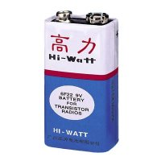
Fig 2.5: Hi-Watt 9V Battery
The most commonly used dry-cell battery is the carbon-zinc dry cell battery. Dry-cell batteries are made by stacking a carbon plate, a layer of electrolyte paste, and a zinc plate alternately until the desired total voltage is achieved. The most common dry-cell batteries have one of the following voltages: 1.5, 3, 6, 9, 22.5, 45, and 90. During the discharge of a carbon-zinc battery, the zinc metal is converted to a zinc salt in the electrolyte, and magnesium dioxide is reduced at the carbon electrode. These actions establish a voltage of approximately 1.5 V.
The lead-acid storage battery may be used. This battery is rechargeable; it consists of lead and lead/dioxide electrodes which are immersed in sulfuric acid. When fully charged, this type of battery has a 2.06-2.14 V potential (A 12 volt car battery uses 6 cells in series). During discharge, the lead is converted to lead sulfate and the sulfuric acid is converted to water. When the battery is charging, the lead sulfate is converted back to lead and lead dioxide A nickel-cadmium battery has become more popular in recent years. This battery cell is completely sealed and rechargeable. The electrolyte is not involved in the electrode reaction, making the voltage constant over the span of the batteries long service life. During the charging process, nickel oxide is oxidized to its higher oxidation state and cadmium oxide is reduced. The nickel-cadmium batteries have many benefits. They can be stored both charged and uncharged. They have a long service life, high current availabilities, constant voltage, and the ability to be recharged. Fig: 2.6 shows pencil battery of 1.5V.
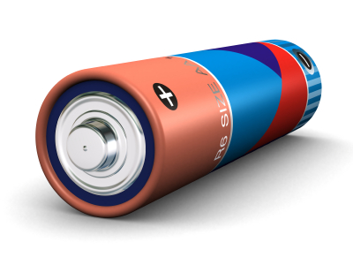
Fig 2.6: Pencil Battery of 1.5V
Rectification:
The process of converting an alternating current to a pulsating direct current is called as rectification. For rectification purpose we use rectifiers.
Rectifiers:
A rectifier is an electrical device that converts alternating current (AC) to direct current (DC), a process known as rectification. Rectifiers have many uses including as components of power supplies and as detectors of radio signals. Rectifiers may be made of solid-state diodes, vacuum tube diodes, mercury arc valves, and other components. A device that it can perform the opposite function (converting DC to AC) is known as an inverter.
When only one diode is used to rectify AC (by blocking the negative or positive portion of the waveform), the difference between the term diode and the term rectifier is merely one of usage, i.e., the term rectifier describes a diode that is being used to convert AC to DC. Almost all rectifiers comprise a number of diodes in a specific arrangement for more efficiently converting AC to DC than is possible with only one diode. Before the development of silicon semiconductor rectifiers, vacuum tube diodes and copper (I) oxide or selenium rectifier stacks were used.
Bridge full wave rectifier:
The Bridge rectifier circuit is shown in fig: 2.7, which converts an ac voltage to dc voltage using both half cycles of the input ac voltage. The Bridge rectifier circuit is shown in the figure. The circuit has four diodes connected to form a bridge. The ac input voltage is applied to the diagonally opposite ends of the bridge. The load resistance is connected between the other two ends of the bridge.
For the positive half cycle of the input ac voltage, diodes D1 and D3 conduct, whereas diodes D2 and D4 remain in the OFF state. The conducting diodes will be in series with the load resistance R_{L} and hence the load current flows through R_{L.}
For the negative half cycle of the input ac voltage, diodes D2 and D4 conduct whereas, D1 and D3 remain OFF. The conducting diodes D2 and D4 will be in series with the load resistance R_{L} and hence the current flows through R_{L} in the same direction as in the previous half cycle. Thus a bi-directional wave is converted into a unidirectional wave.
Input Output
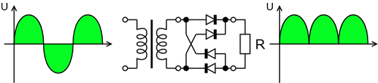
Fig 2.7.1: Bridge rectifier: a full-wave rectifier using 4 diodes
DB107:
Now -a -days Bridge rectifier is available in IC with a number of DB107. In our project we are using an IC in place of bridge rectifier. The picture of DB 107 is shown in fig: 2.8.
Features:
- Good for automation insertion
- Surge overload rating - 30 amperes peak
- Ideal for printed circuit board
- Reliable low cost construction utilizing molded
- Glass passivated device
- Polarity symbols molded on body
- Mounting position: Any
- Weight: 1.0 gram
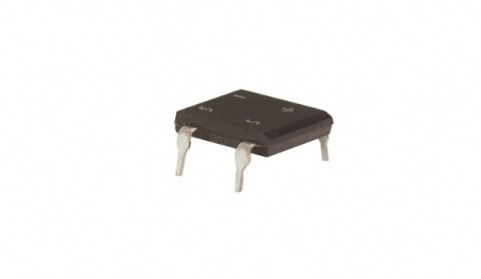
Fig 2.8.2: DB107
Filtration:
The process of converting a pulsating direct current to a pure direct current using filters is called as filtration.
Filters: Electronic filters are electronic circuits, which perform signal-processing functions, specifically to remove unwanted frequency components from the signal, to enhance wanted ones.
Introduction to Capacitors:
The Capacitor or sometimes referred to as a Condenser is a passive device, and one which stores energy in the form of an electrostatic field which produces a potential (static voltage) across its plates. In its basic form a capacitor consists of two parallel conductive plates that are not connected but are electrically separated either by air or by an insulating material called the Dielectric. When a voltage is applied to these plates, a current flows charging up the plates with electrons giving one plate a positive charge and the other plate an equal and opposite negative charge This flow of electrons to the plates is known as the Charging Current and continues to flow until the voltage across the plates (and hence the capacitor) is equal to the applied voltage Vcc. At this point the capacitor is said to be fully charged and this is illustrated below. The construction of capacitor and an electrolytic capacitor are shown in figures 2.9 and 2.10 respectively.
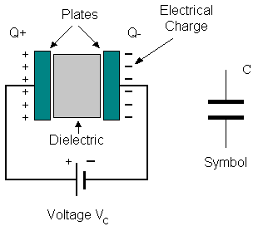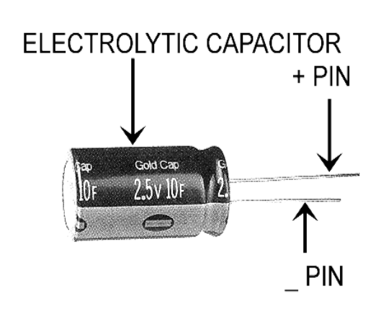
Fig 2.9:Construction Of a Capacitor Fig 2.10:Electrolytic Capaticor
Units of Capacitance:
Microfarad (μF) 1μF = 1/1,000,000 = 0.000001 = 10-6 F
Nanofarad (nF) 1nF = 1/1,000,000,000 = 0.000000001 = 10⁻⁹ F
Pico farad (pF) 1pF = 1/1,000,000,000,000 = 0.000000000001 = 10⁻¹² F
Operation of Capacitor:
Think of water flowing through a pipe. If we imagine a capacitor as being a storage tank with an inlet and an outlet pipe, it is possible to show approximately how an electronic capacitor works.
First, let's consider the case of a "coupling capacitor" where the capacitor is used to connect a signal from one part of a circuit to another but without allowing any direct current to flow.
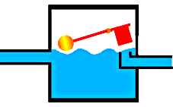 | If the current flow is alternating between zero and a maximum, our "storage tank" capacitor will allow the current waves to pass through.
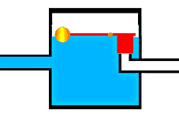 | However, if there is a steady current, only the initial short burst will flow until the "floating ball valve" closes and stops further flow.
So a coupling capacitor allows "alternating current" to pass through because the ball valve doesn't get a chance to close as the waves go up and down. However, a steady current quickly fills the tank so that all flow stops.
A capacitor will pass alternating current but (apart from an initial surge) it will not pass d.c.
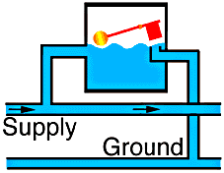 | Where a capacitor is used to decouple a circuit, the effect is to "smooth out ripples". Any ripples, waves or pulses of current are passed to ground while d.c. Flows smoothly.
Regulation:
The process of converting a varying voltage to a constant regulated voltage is called as regulation. For the process of regulation we use voltage regulators.
Voltage Regulator:
A voltage regulator (also called a ‘regulator) with only three terminals appears to be a simple device, but it is in fact a very complex integrated circuit. It converts a varying input voltage into a constant ‘regulated’ output voltage. Voltage Regulators are available in a variety of outputs like 5V, 6V, 9V, 12V and 15V. The LM78XX series of voltage regulators are designed for positive input. For applications requiring negative input, the LM79XX series is used. Using a pair of ‘voltage-divider’ resistors can increase the output voltage of a regulator circuit.
It is not possible to obtain a voltage lower than the stated rating. You cannot use a 12V regulator to make a 5V power supply. Voltage regulators are very robust. These can withstand over-current draw due to short circuits and also over-heating. In both cases, the regulator will cut off before any damage occurs. The only way to destroy a regulator is to apply reverse voltage to its input. Reverse polarity destroys the regulator almost instantly. Fig: 2.11 shows voltage regulator.
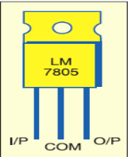.
Fig 2.11: voltage Regulator
Resistors:
A resistor is a two-terminal electronic component that produces a voltage across its terminals that is proportional to the electric current passing through it in accordance with Ohm's law:
V = IR
Resistors are elements of electrical networks and electronic circuits and are ubiquitous in most electronic equipment. Practical resistors can be made of various compounds and films, as well as resistance wire (wire made of a high-resistivity alloy, such as nickel/chrome).
The primary characteristics of a resistor are the resistance, the tolerance, maximum working voltage and the power rating. Other characteristics include temperature coefficient, noise, and inductance. Less well-known is critical resistance, the value below which power dissipation limits the maximum permitted current flow, and above which the limit is applied voltage. Critical resistance is determined by the design, materials and dimensions of the resistor.
Resistors can be made to control the flow of current, to work as Voltage dividers, to dissipate power and it can shape electrical waves when used in combination of other components. Basic unit is ohms.
Theory of operation:

Ohm's law:

The behavior of an ideal resistor is dictated by the relationship specified in Ohm's law:
V = IR
Ohm's law states that the voltage (V) across a resistor is proportional to the current (I) through it where the constant of proportionality is the resistance (R).

Power dissipation:
The power dissipated by a resistor (or the equivalent resistance of a resistor network) is calculated using the following:
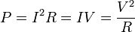
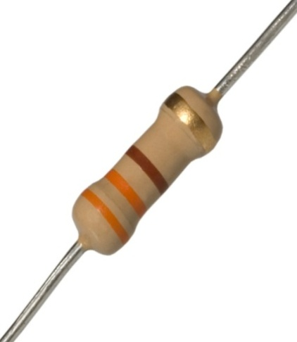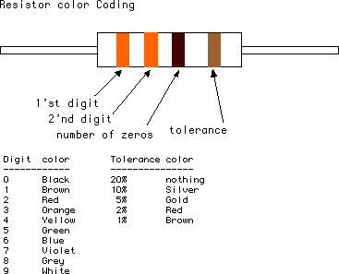

Fig 2.12: Resistor Fig 2.13: Color Bands In Resistor

2.2.3 LED:
A light-emitting diode (LED) is a semiconductor light source. LEDs are used as indicator lamps in many devices, and are increasingly used for lighting. Introduced as a practical electronic component in 1962, early LEDs emitted low-intensity red light, but modern versions are available across the visible, ultraviolet and infrared wavelengths, with very high brightness. The internal structure and parts of a led are shown in figures 2.14 and 2.15 respectively.
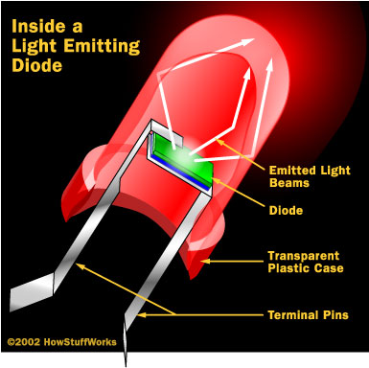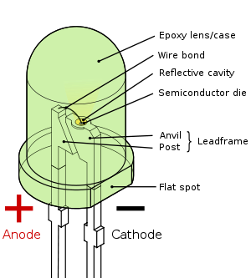
Fig 2.14: Inside a LED Fig 2.15: Parts of a LED
Working:
The structure of the LED light is completely different than that of the light bulb. Amazingly, the LED has a simple and strong structure. The light-emitting semiconductor material is what determines the LED's color. The LED is based on the semiconductor diode.
When a diode is forward biased (switched on), electrons are able to recombine with holes within the device, releasing energy in the form of photons. This effect is called electroluminescence and the color of the light (corresponding to the energy of the photon) is determined by the energy gap of the semiconductor. An LED is usually small in area (less than 1 mm²), and integrated optical components are used to shape its radiation pattern and assist in reflection. LEDs present many advantages over incandescent light sources including lower energy consumption, longer lifetime, improved robustness, smaller size, faster switching, and greater durability and reliability. However, they are relatively expensive and require more precise current and heat management than traditional light sources. Current LED products for general lighting are more expensive to buy than fluorescent lamp sources of comparable output.They also enjoy use in applications as diverse as replacements for traditional light sources in automotive lighting (particularly indicators) and in traffic signals. The compact size of LEDs has allowed new text and video displays and sensors to be developed, while their high switching rates are useful in advanced communications technology. The electrical symbol and polarities of led are shown in fig 2.17
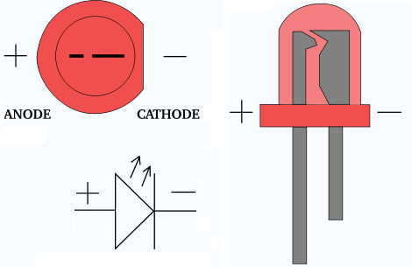
Fig 2.16: Electrical Symbol & Polarities of LED
LED lights have a variety of advantages over other light sources:
- High-levels of brightness and intensity
- High-efficiency
- Low-voltage and current requirements
- Low radiated heat
- High reliability (resistant to shock and vibration)
- No UV Rays
- Long source life
- Can be easily controlled and programmed
Applications of LED fall into three major categories:
- Visual signal application where the light goes more or less directly from the LED to the human eye, to convey a message or meaning.
- Illumination where LED light is reflected from object to give visual response of these objects.
- Generate light for measuring and interacting with processes that do not involve the human visual system.
2.3 MOSFET
The metal–oxide–semi conductor field-effect transistor (MOSFET, MOS-FET, or MOS FET) is a transistor used for amplifying or switching electronic signals. Although the MOSFET is a four-terminal device with source (S), gate (G), drain (D), and body (B) terminals,^{[1]} the body (or substrate) of the MOSFET often is connected to the source terminal, making it a three-terminal device like other field-effect transistors. When two terminals are connected to each other (short-circuited) only three terminals appear in electrical diagrams. The MOSFET is by far the most common transistor in both digital and analog circuits, though the bipolar junction transistor was at one time much more common.
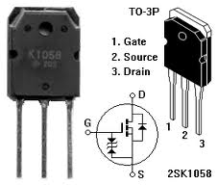
In enhancement mode MOSFETs, a voltage drop across the oxide induces a conducting channel between the source and drain contacts via the field effect. The term "enhancement mode" refers to the increase of conductivity with increase in oxide field that adds carriers to the channel, also referred to as the inversion layer. The channel can contain electrons (called an nMOSFET or nMOS), or holes (called a pMOSFET or pMOS), opposite in type to the substrate, so nMOS is made with a p-type substrate, and pMOS with an n-type substrate (see article on semiconductor devices). In the less common depletion mode MOSFET, described further later on, the channel consists of carriers in a surface impurity layer of opposite type to the substrate, and conductivity is decreased by application of a field that depletes carriers from this surface layer.
The 'metal' in the name MOSFET is now often a misnomer because the previously metal gate material is now often a layer of polysilicon (polycrystalline silicon). Aluminum had been the gate material until the mid 1970s, when polysilicon became dominant, due to its capability to form self-aligned gates. Metallic gates are regaining popularity, since it is difficult to increase the speed of operation of transistors without metal gates.
Likewise, the 'oxide' in the name can be a misnomer, as different dielectric materials are used with the aim of obtaining strong channels with applied smaller voltages.
An insulated-gate field-effect transistor or IGFET is a related term almost synonymous with MOSFET. The term may be more inclusive, since many "MOSFETs" use a gate that is not metal, and a gate insulator that is not oxide. Another synonym is MISFET for metal–insulator–semiconductor FET.
A variety of symbols are used for the MOSFET. The basic design is generally a line for the channel with the source and drain leaving it at right angles and then bending back at right angles into the same direction as the channel. Sometimes three line segments are used for enhancement mode and a solid line for depletion mode. Another line is drawn parallel to the channel for the gate.
The bulk connection, if shown, is shown connected to the back of the channel with an arrow indicating PMOS or NMOS. Arrows always point from P to N, so an NMOS (N-channel in P-well or P-substrate) has the arrow pointing in (from the bulk to the channel). If the bulk is connected to the source (as is generally the case with discrete devices) it is sometimes angled to meet up with the source leaving the transistor. If the bulk is not shown (as is often the case in IC design as they are generally common bulk) an inversion symbol is sometimes used to indicate PMOS, alternatively an arrow on the source may be used in the same way as for bipolar transistors (out for nMOS, in for pMOS).
Comparison of enhancement-mode and depletion-mode MOSFET symbols, along with JFET symbols (drawn with source and drain ordered such that higher voltages appear higher on the page than lower voltages):
For the symbols in which the bulk, or body, terminal is shown, it is here shown internally connected to the source. This is a typical configuration, but by no means the only important configuration. In general, the MOSFET is a four-terminal device, and in integrated circuits many of the MOSFETs share a body connection, not necessarily connected to the source terminals of all the transistors.
2.4 Mono Stable Multi Vibrator

Mono stable multi Vibrator IC CD4047:

IC CD 4047 is mainly used in Inverter circuits. It's very compact and has a very high life in inverter circuits. CD4047B consists of a gatable astable multi vibrator with logic techniques incorporated to permit positive or negative edge-triggered mono stable multi vibrator action with retriggering and external counting options. CD 4047 is the low power Mono stable / Astable Multi vibrator that require only an external capacitor and a resistor to give the output pulses.
The values of these components determine the output pulse width in the Monostable mode and output frequency in the Astable mode.
Multivibrator creates an electrical signal that changes state on a regular basis (astable) or on demand (monostable). One of the benefits of the 4047 is being able to do so as well, but with fewer external components.

Features
- Lower power consumption: special CMOS oscillator configuration
- Monostable (one-shot) or astable (free-running) operation
- True and complemented buffered outputs
Monostable mode
Monostable mode can be obtained by triggering the + input of the IC using a low to high pulse or by a high to low pulse at the – input. The IC can be retriggered by applying simultaneous low to high pulse in both the + and – inputs.
Astable mode
This can be obtained by keeping a high / low level at the Astable input. Output frequency depends on the timing components.
Pin connections of CD4047
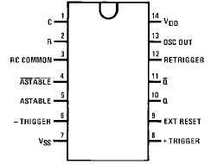
CD 4047 is a low power CMOS IC that can operate between 3 to 15 volts DC.
Description:
This is the schematic of a simple 40W , 12 volts to 220 Volts inverter. You don’t believe, this is simple and cheap and working for me for last 4 years. The heart of the circuit is a CD 4047 IC which is wired as an astable multi vibrator here Resistance and Capacitance at pin 1&2 determines the out put frequency. Here it is set to 60Hz.Due to this a two 180 degree out of phase ,120 Hz , 50% duty cycle waveforms will appear at pin 10 & 11.These waves are amplified by the complementary symmetry amplifier.
The circuit diagram is the typical application of the IC CD4047 in the Monostable mode. The timing elements are the capacitor C1 connected between the pins 1 and 3and the resistor R1 between pins 2 and 3. When a low to high pulse is applied to its pin 8 and 12, output pulse will be available from pins 10 and 11.
Output pulse width depends on the values of R1 and C1 which can be determined using the formula 2.48 R.C. R1 should be between 10k and 10M. Design of CD4047 in different modes is given in the function table of the data sheet provided.
The CD4047B is capable of operating in either the monostable or astable mode. It requires an external capacitor (between pins 1 and 3) and an external resistor (between pins 2 and 3) to determine the output pulse width in the monostable mode, and the output frequency in the astable mode.
There are three outputs, Q, and OSC out. Q is the normal output, is the inverse of Q – that is if Q is high, is low – at the same frequency. OSC output provides a signal that is very close to twice the frequency of Q.

4047 IC Applications
- Frequency discriminators
- Timing circuits
- Time-delay applications
- Envelope detection
- Frequency multiplication
- Frequency division
2.5 D.C. Motor:
A dc motor uses electrical energy to produce mechanical energy, very typically through the interaction of magnetic fields and current-carrying conductors. The reverse process, producing electrical energy from mechanical energy, is accomplished by an alternator, generator or dynamo. Many types of electric motors can be run as generators, and vice versa. The input of a DC motor is current/voltage and its output is torque (speed).

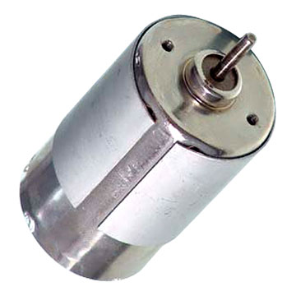
Fig 2.17: DC Motor
The DC motor has two basic parts: the rotating part that is called the armature and the stationary part that includes coils of wire called the field coils. The stationary part is also called the stator. Figure shows a picture of a typical DC motor, Figure shows a picture of a DC armature, and Fig shows a picture of a typical stator. From the picture you can see the armature is made of coils of wire wrapped around the core, and the core has an extended shaft that rotates on bearings. You should also notice that the ends of each coil of wire on the armature are terminated at one end of the armature. The termination points are called the commutator, and this is where the brushes make electrical contact to bring electrical current from the stationary part to the rotating part of the machine.
Operation:
The DC motor you will find in modem industrial applications operates very similarly to the simple DC motor described earlier in this chapter. Figure 12-9 shows an electrical diagram of a simple DC motor. Notice that the DC voltage is applied directly to the field winding and the brushes. The armature and the field are both shown as a coil of wire. In later diagrams, a field resistor will be added in series with the field to control the motor speed.
When voltage is applied to the motor, current begins to flow through the field coil from the negative terminal to the positive terminal. This sets up a strong magnetic field in the field winding. Current also begins to flow through the brushes into a commutator segment and then through an armature coil. The current continues to flow through the coil back to the brush that is attached to other end of the coil and returns to the DC power source. The current flowing in the armature coil sets up a strong magnetic field in the armature.
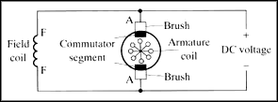
Fig 2.18: Simple electrical diagram of DC motor
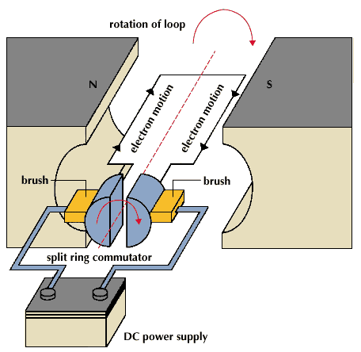
Fig 2.19: Operation of a DC Motor
The magnetic field in the armature and field coil causes the armature to begin to rotate. This occurs by the unlike magnetic poles attracting each other and the like magnetic poles repelling each other. As the armature begins to rotate, the commutator segments will also begin to move under the brushes. As an individual commutator segment moves under the brush connected to positive voltage, it will become positive, and when it moves under a brush connected to negative voltage it will become negative. In this way, the commutator segments continually change polarity from positive to negative. Since the commutator segments are connected to the ends of the wires that make up the field winding in the armature, it causes the magnetic field in the armature to change polarity continually from north pole to south pole. The commutator segments and brushes are aligned in such a way that the switch in polarity of the armature coincides with the location of the armature's magnetic field and the field winding's magnetic field. The switching action is timed so that the armature will not lock up magnetically with the field. Instead the magnetic fields tend to build on each other and provide additional torque to keep the motor shaft rotating
When the voltage is de-energized to the motor, the magnetic fields in the armature and the field winding will quickly diminish and the armature shaft's speed will begin to drop to zero. If voltage is applied to the motor again, the magnetic fields will strengthen and the armature will begin to rotate again.
Types of DC motors:
1. DC Shunt Motor,
2. DC Series Motor,
3. DC Long Shunt Motor (Compound)
4. DC Short Shunt Motor (Compound)
The rotational energy that you get from any motor is usually the battle between two magnetic fields chasing each other. The DC motor has magnetic poles and an armature, to which DC electricity is fed, The Magnetic Poles are electromagnets, and when they are energized, they produce a strong magnetic field around them, and the armature which is given power with a commutator, constantly repels the poles, and therefore rotates.
1. The DC Shunt Motor:
In a 2 pole DC Motor, the armature will have two separate sets of windings, connected to a commutator at the end of the shaft that are in constant touch with carbon brushes. The brushes are static, and the commutator rotate and as the portions of the commutator touching the respective positive or negative polarity brush will energize the respective part of the armature with the respective polarity. It is usually arranged in such a way that the armature and the poles are always repelling.
The general idea of a DC Motor is, the stronger the Field Current, the stronger the magnetic field, and faster the rotation of the armature. When the armature revolves between the poles, the magnetic field of the poles induce power in the armature conductors, and some electricity is generated in the armature, which is called back emf, and it acts as a resistance for the armature. Generally an armature has resistance of less than 1 Ohm, and powering it with heavy voltages of Direct Current could result in immediate short circuits. This back emf helps us there.
When an armature is loaded on a DC Shunt Motor, the speed naturally reduces, and therefore the back emf reduces, which allows more armatures current to flow. This results in more armature field, and therefore it results in torque.
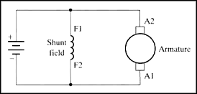
Fig: Diagram of DC shunt motor
When a DC Shunt Motor is overloaded, if the armature becomes too slow, the reduction of the back emf could cause the motor to burn due to heavy current flow thru the armature.
The poles and armature are excited separately, and parallel, therefore it is called a Shunt Motor.
2. The DC Series Motor:
Fig: Diagram of DC series motor
A DC Series Motor has its field coil in series with the armature. Therefore any amount of power drawn by the armature will be passed thru the field. As a result you cannot start a Series DC Motor without any load attached to it. It will either run uncontrollably in full speed, or it will stop.
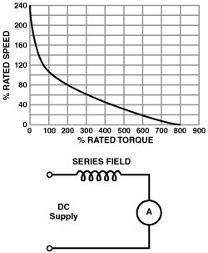
Fig: Diagram of DC series motor graph representation
When the load is increased then its efficiency increases with respect to the load applied. So these are on Electric Trains and elevators.
3. DC Compound Motor:
A compound of Series and Shunt excitation for the fields is done in a Compound DC Motor. This gives the best of both series and shunt motors. Better torque as in a series motor, while the possibility to start the motor with no load.
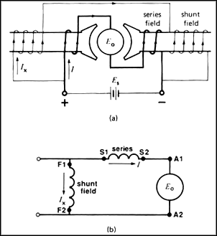
Fig: Diagram of DC compound motor
Above is the diagram of a long shunt motor, while in a short shunt, the shunt coil will be connected after the serial coil. A Compound motor can be run as a shunt motor without connecting the serial coil at all but not vice versa.
Applications of DC Motors:
1. Electric Train: A kind of DC motor called the DC Series Motor is used in Electric Trains. The DC Series Motors have the property to deliver more power when they are loaded more. So the more the people get on a train, the more powerful the train becomes.
2. Elevators: The best bidirectional motors are DC motors. They are used in elevators. Compound DC Motors are used for this application.
3. PC Fans, CD ROM Drives, and Hard Drives: All these things need motors, very miniature motors, with great precision. AC motors can never imagine any application in these places.
4. Starter Motors in Automobiles: An automobile battery supplies DC, so a DC motor is best suited here. Also, you cannot start an engine with a small sized AC motor,
5. Electrical Machines Lab in Colleges.
H Bridge
With switches:
An H bridge is an electronic circuit that enables a voltage to be applied across a load in either direction. These circuits are often used in robotics and other applications to allow DC motors to run forwards and backwards.
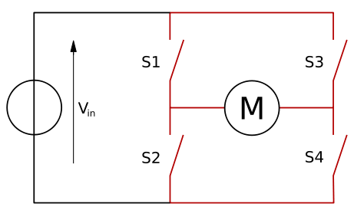
When the switches S1 and S4 (according to the first figure) are closed (and S2 and S3 are open) a positive voltage will be applied across the motor. By opening S1 and S4 switches and closing S2 and S3 switches, this voltage is reversed, allowing reverse operation of the motor.
Using the nomenclature above, the switches S1 and S2 should never be closed at the same time, as this would cause a short circuit on the input voltage source. The same applies to the switches S3 and S4. This condition is known as shoot-through.
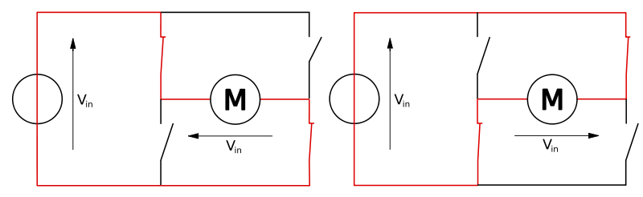
The H-bridge arrangement is generally used to reverse the polarity of the motor, but can also be used to 'brake' the motor, where the motor comes to a sudden stop, as the motor's terminals are shorted, or to let the motor 'free run' to a stop, as the motor is effectively disconnected from the circuit. The following table summarizes operation, with S1-S4 corresponding to the diagram above.

S1 | S2 | S3 | S4 | Result
1 | 0 | 0 | 1 | Motor moves right
0 | 1 | 1 | 0 | Motor moves left
0 | 0 | 0 | 0 | Motor free runs
0 | 1 | 0 | 1 | Motor brakes
1 | 0 | 1 | 0 | Motor brakes
1 | 1 | 0 | 0 | Shoot-through
0 | 0 | 1 | 1 | Shoot-through
1 | 1 | 1 | 1 | Shoot-through

With relays:
If you connect up these relay circuits, remember to put a diode across the coil of the relay. This will keep the spike voltage (back EMF), coming out of the coil of the relay, from getting into the MCU and damaging it. The anode, which is the arrow side of the diode, should connect to ground. The bar, which is the Cathode side of the diode, should connect to the coil where the MCU connects to the relay.
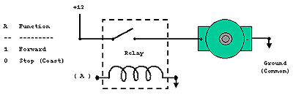
If you connect this circuit to a small hobby motor you can control the motor with a processor (MCU, etc.) Applying a logical one, (+12 Volts in our example) to point A causes the motor to turn forward. Applying a logical zero, (ground) causes the motor to stop turning (to coast and stop).
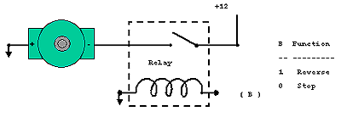
Hook the motor up in this fashion and the circuit turns the motor in reverse when you apply a logical one (+12Volts) to point B. Apply a logical zero, which is usually a ground, causes the motor to stop spinning.

If you hook up these circuits you can only get the motor to stop or turn in one direction, forward for the first circuit or reverse for the second circuit.
You can also pulse the motor control line, (A or B) on and off. This powers the motor in short burst and gets varying degrees of torque, which usually translates into variable motor speed.But if you want to be able to control the motor in both forward and reverse with a processor, you will need more circuitry. You will need an H-Bridge. Notice the "H"-looking configuration in the next graphic. Relays configured in this fashion make an H-Bridge. The "high side drivers" are the relays that control the positive voltage to the motor. This is called sourcing current.

The "low side drivers" are the relays that control the negative voltage to sink current to the motor. "Sinking current" is the term for connecting the circuit to the negative side of the power supply, which is usually ground.
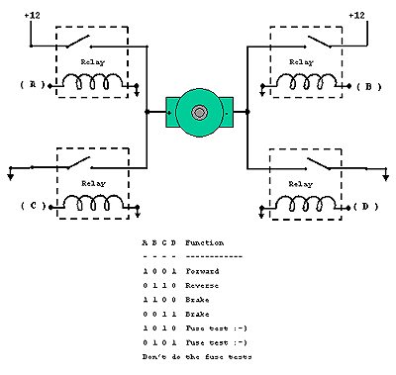
So, you turn on the upper left and lower right circuits, and power flows through the motor forward, i.e.: 1 to A, 0 to B, 0 to C, and 1 to D.
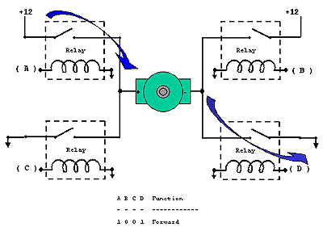
Then for reverse you turn on the upper right and lower left circuits and power flows through the motor in reverse, i.e.: 0 to A, 1 to B, 1 to C, and 0 to D.
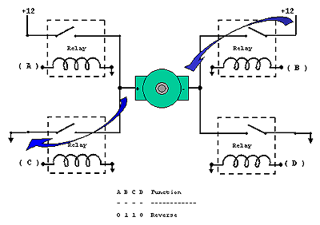
You should be careful not to turn on both circuits on one side and the other, or you have a direct short which will destroy your circuit; Example: A and C or B and D both high (logical 1).
With transistors:
We can better control our motor by using transistors or Field Effect Transistors (FETs).Most of what we have discussed about the relays H-Bridge is true of these circuits. You don't need diodes that were across the relay coils now. You should use diodes across your transistors though. See the following diagram showing how they are connected.
These solid state circuits provide power and ground connections to the motor, as did the relay circuits. The high side drivers need to be current "sources" which is what PNP transistors and P-channel FETs are good at. The low side drivers need to be current "sinks" which is what NPN transistors and N-channel FETs are good at.
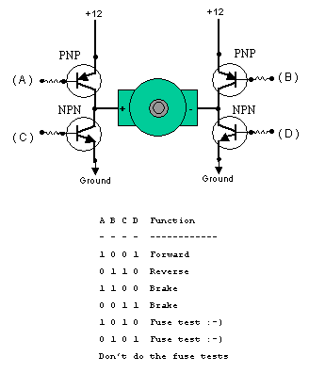
If you turn on the two upper circuits, the motor resists turning, so you effectively have a breaking mechanism. The same is true if you turn on both of the lower circuits. This is because the motor is a generator and when it turns it generates a voltage. If the terminals of the motor are connected (shorted), then the voltage generated counteracts the motors freedom to turn. It is as if you are applying a similar but opposite voltage to the one generated by the motor being turned. Vis-ã-vis, it acts like a brake.
To be nice to your transistors, you should add diodes to catch the back voltage that is generated by the motor's coil when the power is switched on and off. This fly back voltage can be many times higher than the supply voltage! If you don't use diodes, you could burn out your transistors.
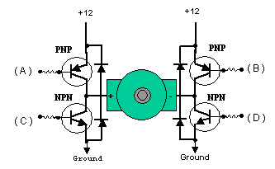
Transistors, being a semiconductor device, will have some resistance, which causes them to get hot when conducting much current. This is called not being able to sink or source very much power, i.e.: Not able to provide much current from ground or from plus voltage.

Mosfets are much more efficient, they can provide much more current and not get as hot. They usually have the flyback diodes built in so you don't need the diodes anymore. This helps guard against flyback voltage frying your MCU.

To use Mosfets in an H-Bridge, you need P-Channel Mosfets on top because they can "source" power, and N-Channel Mosfets on the bottom because then can "sink" power. N-Channel Mosfets are much cheaper than P-Channel Mosfets, but N-Channel Mosfets used to source power require about 7 volts more than the supply voltage, to turn on. As a result, some people manage to use N-Channel Mosfets, on top of the H-Bridge, by using cleaver circuits to overcome the breakdown voltage.

It is important that the four quadrants of the H-Bridge circuits be turned on and off properly. When there is a path between the positive and ground side of the H-Bridge, other than through the motor, a condition exists called "shoot through". This is basically a direct short of the power supply and can cause semiconductors to become ballistic, in circuits with large currents flowing. There are H-bridge chips available that are much easier, and safer, to use than designing your own H-Bridge circuit.

H-Bridge Devices
The L293 has 2 H-Bridges, can provide about 1amp to each and occasional peak loads to 2 amps. Motors typically controlled with this controller are near the size of a 35 mm film plastic canister.

The L298 has 2 h-bridges on board, can handle 1amp and peak current draws to about 3amps. You often see motors between the size a of 35 mm film plastic canister and a coke can, driven by this type H-Bridge. The LMD18200 has one h-bridge on board, can handle about 2 or 3 amps and can handle a peak of about 6 amps. This H-Bridge chip can usually handle an average motor about the size of a coke. There are several more commercially designed H-Bridge chips as well.

Schematic diagram:
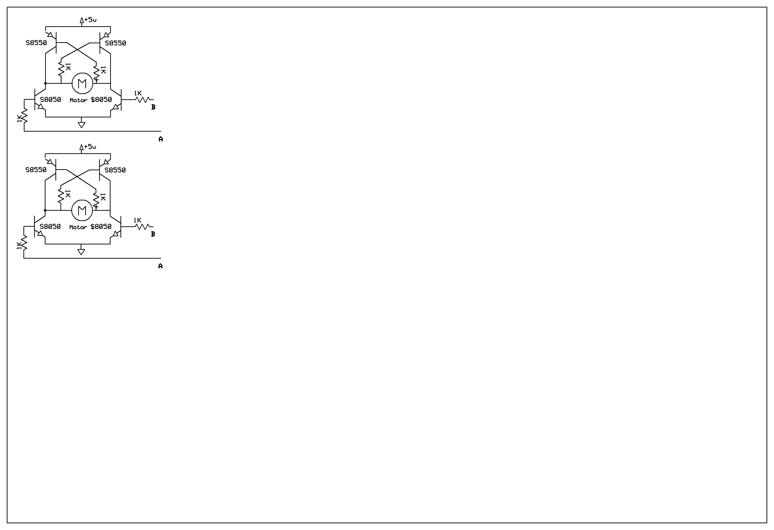
Features:
• Delivers up to 5 A continuous 6 A peak current
• Optimized for DC motor management applications
• Operates at supply voltages up to 40 V
• Very low RDS ON
; typ. 200 mΩ @ 25 °C per switch
• Output full short circuit protected
• Overtemperature protection with hysteresis and diagnosis
• Short circuit and open load diagnosis
With open drain error flag
• Undervoltage lockout
• CMOS/TTL compatible inputs with hysteresis
• No crossover current
• Internal freewheeling diodes
• Wide temperature range; − 40 °C < Tj
< 150 °C

2.6 Potentiometer:
A potentiometer (colloquially known as a "pot") is a three-terminal resistor with a sliding contact that forms an adjustable voltage divider.^{[1]} If only two terminals are used (one side and the wiper), it acts as a variable resistor or rheostat. Potentiometers are commonly used to control electrical devices such as volume controls on audio equipment. Potentiometers operated by a mechanism can be used as position transducers, for example, in a joystick.
Potentiometers are rarely used to directly control significant power (more than a watt). Instead they are used to adjust the level of analog signals (e.g. volume controls on audio equipment), and as control inputs for electronic circuits. For example, a light dimmer uses a potentiometer to control the switching of a TRIAC and so indirectly control the brightness of lamps.

Theory of operation:
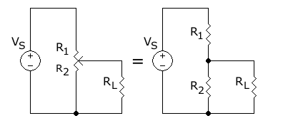
The potentiometer can be used as a voltage divider to obtain a manually adjustable output voltage at the slider (wiper) from a fixed input voltage applied across the two ends of the pot. This is the most common use of pots.
The voltage across R_{L} can be calculated by:
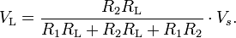
If R_{L} is large compared to the other resistances (like the input to an operational amplifier), the output voltage can be approximated by the simpler equation:
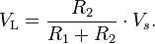
As an example, assume
, , , and
Since the load resistance is large compared to the other resistances, the output voltage V_{L} will be approximately:
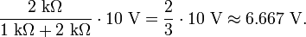
Due to the load resistance, however, it will actually be slightly lower: ≈ 6.623 V.
One of the advantages of the potential divider compared to a variable resistor in series with the source is that, while variable resistors have a maximum resistance where some current will always flow, dividers are able to vary the output voltage from maximum (V_{S}) to ground (zero volts) as the wiper moves from one end of the pot to the other. There is, however, always a small amount of contact resistance.
In addition, the load resistance is often not known and therefore simply placing a variable resistor in series with the load could have a negligible effect or an excessive effect, depending on the load.

Potentiometer construction:
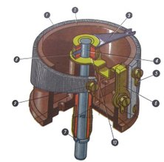
Fig: Diagram of internal construction of potentiometer
Construction of a wire-wound circular potentiometer:
The resistive element (1) of the shown device is trapezoidal, giving a non-linear relationship between resistance and turn angle. The wiper (3) rotates with the axis (4), providing the changeable resistance between the wiper contact (6) and the fixed contacts (5) and (9). The vertical position of the axis is fixed in the body (2) with the ring (7) (below) and the bolt (8) (above).
A potentiometer is constructed with a resistive element formed into an arc of a circle, and a sliding contact (wiper) traveling over that arc.
The resistive element, with a terminal at one or both ends, is flat or angled, and is commonly made of graphite, although other materials may be used. The wiper is connected through another sliding contact to another terminal. On panel pots, the wiper is usually the center terminal of three. For single-turn pots, this wiper typically travels just under one revolution around the contact. "Multi turn" potentiometers also exist, where the resistor element may be helical and the wiper may move 10, 20, or more complete revolutions, though multi turn pots are usually constructed of a conventional resistive element wiped via a worm gear. Besides graphite, materials used to make the resistive element include resistance wire, carbon particles in plastic, and a ceramic/metal mixture called cermets.
One form of rotary potentiometer is called a String potentiometer. It is a multi-turn potentiometer operated by an attached reel of wire turning against a spring. It is used as a position transducer.
In a linear slider pot, a sliding control is provided instead of a dial control. The resistive element is a rectangular strip, not semi-circular as in a rotary potentiometer. Due to the large opening slot or the wiper, this type of pot has a greater potential for getting contaminated.
Potentiometers can be obtained with either linear or logarithmic relations between the slider position and the resistance (potentiometer laws or "tapers"). A letter code ("A" taper, "B" taper, etc.) may be used to identify which taper is intended, but the letter code definitions are variable over time and between manufacturers.
Manufacturers of conductive track potentiometers use conductive polymer resistor pastes that contain hard wearing resins and polymers, solvents, lubricant and carbon – the constituent that provides the conductive/resistive properties. The tracks are made by screen printing the paste onto a paper based phenolic substrate and then curing it in an oven. The curing process removes all solvents and allows the conductive polymer to polymerize and cross link. This produces a durable track with stable electrical resistance throughout its working life.

Types of potentiometers:
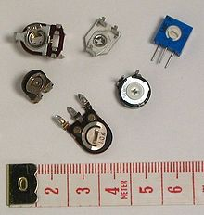
PCB mount trimmer potentiometers, or "trimpots", intended for infrequent adjustment.

1. Linear taper potentiometer
A linear taper potentiometer has a resistive element of constant cross-section, resulting in a device where the resistance between the contact (wiper) and one end terminal is proportional to the distance between them. Linear taper describes the electrical characteristic of the device, not the geometry of the resistive element. Linear taper potentiometers are used when an approximately proportional relation is desired between shaft rotation and the division ratio of the potentiometer; for example, controls used for adjusting the centering of (an analog) cathode-ray oscilloscope.

2. Logarithmic potentiometer
A logarithmic taper potentiometer has a resistive element that either 'tapers' in from one end to the other, or is made from a material whose resistivity varies from one end to the other. This results in a device where output voltage is a logarithmic function of the mechanical angle of the pot.
Most (cheaper) "log" pots are actually not logarithmic, but use two regions of different resistance (but constant resistivity) to approximate a logarithmic law. A log pot can also be simulated with a linear pot and an external resistor. True log pots are significantly more expensive.
Logarithmic taper potentiometers are often used in connection with audio amplifiers.
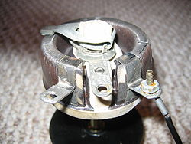
A high power wire wound potentiometer. Any potentiometer may be connected as a rheostat.

3. Rheostat:
The most common way to vary the resistance in a circuit is to use a variable resistor or a rheostat. A rheostat is a two-terminal variable resistor. Often these are designed to handle much higher voltage and current. Typically these are constructed as a resistive wire wrapped to form a toroid coil with the wiper moving over the upper surface of the toroid, sliding from one turn of the wire to the next. Sometimes a rheostat is made from resistance wire wound on a heat-resisting cylinder with the slider made from a number of metal fingers that grip lightly onto a small portion of the turns of resistance wire. The "fingers" can be moved along the coil of resistance wire by a sliding knob thus changing the "tapping" point. They are usually used as variable resistors rather than variable potential dividers.
Any three-terminal potentiometer can be used as a two-terminal variable resistor by not connecting to the third terminal. It is common practice to connect the wiper terminal to the unused end of the resistance track to reduce the amount of resistance variation caused by dirt on the track.

4. Digital potentiometer
A digital potentiometer is an electronic component that mimics the functions of analog potentiometers. Through digital input signals, the resistance between two terminals can be adjusted, just as in an analog potentiometer.

5. Membrane Potentiometer
A membrane potentiometer uses a conductive membrane that is deformed by a sliding element to contact a resistor voltage divider. Linearity can range from 0.5% to 5% depending on the material, design and manufacturing process. The repeat accuracy is typically between 0.1mm and 1.0mm with a theoretically infinite resolution. The service life of these types of potentiometers is typically 1 million to 20 million cycles depending on the materials used during manufacturing and the actuation method; contact and contactless (magnetic) methods are available. Many different material variations are available such as PET(foil), FR4, and Kapton. Membrane potentiometer manuafacturers offer linear, rotary, and application-specific variations. The linear versions can range from 9mm to 1000mm in length and the rotary versions range from 0° to 360°(multi-turn), with each having a height of 0.5mm. Membrane potentiometers can be used for position sensing.

Applications of Potentiometer:
Potentiometers are widely used as user controls, and may control a very wide variety of equipment functions. The widespread use of potentiometers in consumer electronics has declined in the 1990s, with digital controls now more common. However they remain in many applications, such as volume controls and as position sensors.

1. Audio control
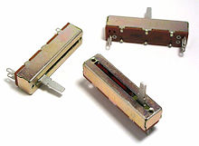
Linear potentiometers ("faders")
One of the most common uses for modern low-power potentiometers is as audio control devices. Both linear pots (also known as "faders") and rotary potentiometers (commonly called knobs) are regularly used to adjust loudness, frequency attenuation and other characteristics of audio signals.
The 'log pot' is used as the volume control in audio amplifiers, where it is also called an "audio taper pot", because the amplitude response of the human ear is also logarithmic. It ensures that, on a volume control marked 0 to 10, for example, a setting of 5 sounds half as loud as a setting of 10. There is also an anti-log pot or reverse audio taper which is simply the reverse of a log pot. It is almost always used in a ganged configuration with a log pot, for instance, in an audio balance control.
Potentiometers used in combination with filter networks act as tone controls or equalizers.

2. Television
Potentiometers were formerly used to control picture brightness, contrast, and color response. A potentiometer was often used to adjust "vertical hold", which affected the synchronization between the receiver's internal sweep circuit (sometimes a multi vibrator) and the received picture signal.

3. Transducers
Potentiometers are also very widely used as a part of displacement transducers because of the simplicity of construction and because they can give a large output signal.

4. Computation
In analog computers, high precision potentiometers are used to scale intermediate results by desired constant factors, or to set initial conditions for a calculation. A motor-driven potentiometer may be used as a function generator, using a non-linear resistance card to supply approximations to trigonometric functions. For example, the shaft rotation might represent an angle, and the voltage division ratio can be made proportional to the cosine of the angle.

2.7 Solar cell/Plate
Solar Panel:

Photovoltaic Cells: Converting Photons to Electrons
The solar cells that you see on calculators and satellites are also called photovoltaic (PV) cells, which as the name implies (photo meaning "light" and voltaic meaning "electricity"), convert sunlight directly into electricity. A module is a group of cells connected electrically and packaged into a frame (more commonly known as a solar panel), which can then be grouped into larger solar arrays.
Photovoltaic cells are made of special materials called semiconductors such as silicon, which is currently used most commonly. Basically, when light strikes the cell, a certain portion of it is absorbed within the semiconductor material. This means that the energy of the absorbed light is transferred to the semiconductor. The energy knocks electrons loose, allowing them to flow freely.
PV cells also all have one or more electric field that acts to force electrons freed by light absorption to flow in a certain direction. This flow of electrons is a current, and by placing metal contacts on the top and bottom of the PV cell, we can draw that current off for external use, say, to power a calculator.
This current, together with the cell's voltage (which is a result of its built-in electric field or fields), defines the power (or wattage) that the solar cell can produce.
Solar Panel Setup:
The use of batteries requires the installation of another component called a charge controller. Batteries last a lot longer if they aren't overcharged or drained too much. That's what a charge controller does. Once the batteries are fully charged, the charge controller doesn't let current from the PV modules continue to flow into them. Similarly, once the batteries have been drained to a certain predetermined level, controlled by measuring battery voltage, many charge controllers will not allow more current to be drained from the batteries until they have been recharged. The use of a charge controller is essential for long battery life.
The other problem besides energy storage is that the electricity generated by your solar panels, and extracted from your batteries if you choose to use them, is not in the form that's supplied by your utility or used by the electrical appliances in your house. The electricity generated by a solar system is direct current, so you'll need an inverter to convert it into alternating current. Most large inverters will allow you to automatically control how your system works. Some PV modules, called AC modules, actually have an inverter already built into each module, eliminating the need for a large, central inverter, and simplifying wiring issues.
Throw in the mounting hardware, wiring, junction boxes, grounding equipment, over current protection, DC and AC disconnects and other accessories, and you have yourself a system. You must follow electrical codes (there's a section in the National Electrical Code just for PV), and it's highly recommended that a licensed electrician who has experience with PV systems do the installation. Once installed, a PV system requires very little maintenance (especially if no batteries are used), and will provide electricity cleanly and quietly for 20 years or more.
Categories of Solar Panel:

POLYCRYSTALLINE MODULES
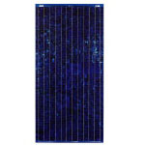
Polycrystalline (or multicrystalline) modules are composed of a number of different crystals, fused together to make a single cell (hence the term 'multi'). They have long been the most popular type of solar module, due to the lower cost in manufacturing the cells. Recently, the cost of monocrystalline has come down, making them more popular in the residential market.
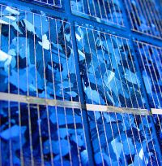
As you can see in the image (left), the construction of these different crystals gives the solar panel a visible crystal grain, or a 'metal flake effect'. They are slightly cheaper to produce than Mono panels, but are also less efficient (anywhere from 0.5% to 2% less efficient depending on the manufacturer). This is because the crystal grain boundaries can trap electrons, which results in lower efficiency.
The BP Solar modules that EnviroGroup installs are approximately 13.5% efficient (meaning that if 100 Watts of potential solar energy strikes the panel, it will produce approximately 13.5 Watts of solar electricity).
These panels are very popular in Australia, and offer a good balance of value vs performance.
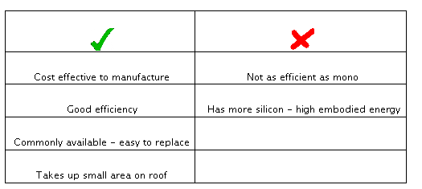

MONOCRYSTALLINE MODULES
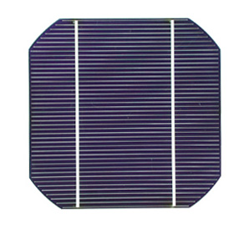
Monocrystalline, as the name suggests, is constructed using one single crystal, cut from ingots. This gives the solar panel a uniform appearance across the entire module. These large single crystals are exceedingly rare, and the process of 'recrystallising' the cell is more expensive to produce.
This technology is now the most widely available in Australia, with the cost of producing monocrystalline cells coming down every year. They are still more expensive than polycrystalline, but can be up to 2% more efficient. EnviroGroup uses SunOwe (14.5%) and Suntech (16.5%) monocrystalline solar modules for our installations.
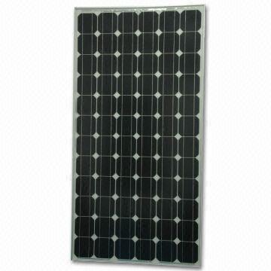
Suntech have recently made some exciting developments in monocrystalline efficiency, with the patent pending Pluto technology. Unique texturing technology, with lower reflectivity, ensures more sunlight can be absorbed throughout the day even without direct solar radiation, and thinner metal lines on the top surface reduces shading loss. Importantly, the process was developed at the University of New South Wales, and has achieved lab efficiency of 25%, and verified efficiency of approx 19%. These panels will be more expensive, but will offer far more solar electricity for less area of solar panel.
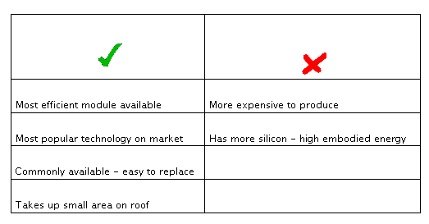
AMORPHOUS MODULES

Amorphous (or 'thin film') solar modules have recently become very popular in the Australian market. They offer better performance in higher temperatures, and have some benefits in shady locations. However, the benefits have been greatly exaggerated by some suppliers, and it is important to weigh that up against the negatives of thin film technology.
The manufacture of these panels is highly automated - silicon is sprayed onto the substrate as a gas (called 'vapour deposition'), which means that the silicon wafer is approx 1 micron thick (compared to approx 200 microns for mono and poly). This means that the panel uses less energy to produce therefore will pay itself back from an energy point of view in a shorter time. However, it also means that the panels are far less efficient than mono or poly (approx 5-6% efficient).
The electrical connections are etched by a laser. Etching these as long horizontal cells across the panel makes these less susceptible from being blocked by shade, but it's important to recognise that there will still be a significant drop-off in performance when the panel is shaded.
Thin-film panels are significantly less efficient than crystalline panels, and a greater number is required for the same output. On average, a thin film solar array will need 2.5 times more roof area than mono or poly. This is critical if you intend to increase the size of your system later, as you may take up all of your north-facing roof for a relatively small system.
One of the biggest selling points of thin film is the performance in hotter temperatures. Unfortunately this has been misrepresented by some suppliers of thin film panels. As an example, if you live in Melbourne, and you are shown a graph that indicates the performance of thin film panels in Alice Springs, it's obvious that those panels won't provide the same advantage in a cooler climate.
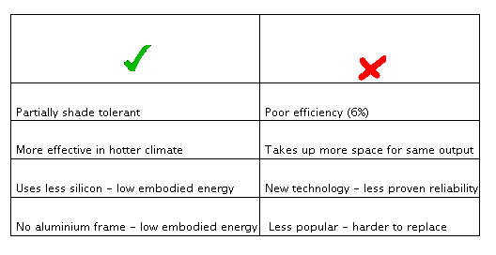
Advantages of Solar Power Generation
The greatest advantage of solar power generation is perhaps its minimal environmental impact. It requires no water for cooling of the system, thus creating no large heat imbalance. Also, no by-products are produced that are detrimental to the environment. Another advantage of solar power generation is that bulky mechanical generators are not needed. The process of electricity generation is quick and the arrays are available in a variety of sizes according to the specific use.
A solar cell or photovoltaic cell is a device that converts solar energy into electricity by the photovoltaic effect. Sometimes the term solar cell is reserved for devices intended specifically to capture energy from sunlight, while the term photovoltaic cell is used when the source is unspecified. Assemblies of cells are used to make solar panel, solar modules, or photovoltaic arrays. Photovoltaic is the field of technology and research related to the application of solar cells for solar energy.

A Solar cell efficiencies vary from 6% for amorphous silicon-based solar cells to 40.7% with multiple-junction research lab cells and 42.8% with multiple dies assembled into a hybrid package. Solar cell energy conversion efficiencies for commercially available multi crystalline Si solar cells are around 14-19%.
Solar cells can also be applied to other electronics devices to make it self-power sustainable in the sun. There are solar cell phone chargers, solar bike light and solar camping lanterns that people can adopt for daily use

Equivalent circuit of a solar cell
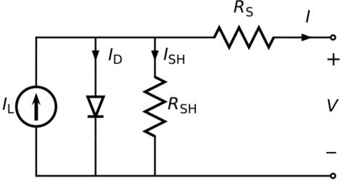
The equivalent circuit of a solar cell
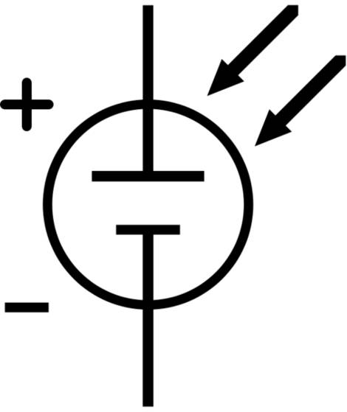
The schematic symbol of a solar cell
1. Photons in sunlight hit the solar panel and are absorbed by semi conducting materials, such as silicon.
2. Electrons (negatively charged) are knocked loose from their atoms, allowing them to flow through the material to produce electricity. Due to the special composition of solar cells, only allow the electrons to move in a single direction. The complementary positive charges that are also created (like bubbles) are called holes and flow in the direction opposite of the electrons in a silicon solar panel.
3. An array of solar panels converts solar energy into a usable amount of direct current (DC) electricity.
2.7.1 Solar energy:
Solar energy, radiant light and heat from the sun, has been harnessed by humans since ancient times using a range of ever-evolving technologies. Solar radiation, along with secondary solar-powered resources such as wind and wave power, hydroelectricity and biomass, account for most of the available renewable energy on earth Only a minuscule fraction of the available solar energy is used.
Solar powered electrical generation relies on heat engines and photovoltaic. Solar energy's uses are limited only by human ingenuity. A partial list of solar applications includes space heating and cooling through solar architecture, potable water via distillation and disinfection, day lighting, solar hot water, solar cooking, and high temperature process heat for industrial purposes. To harvest the solar energy, the most common way is to use solar panels.
Solar technologies are broadly characterized as either passive solar or active solar depending on the way they capture, convert and distribute solar energy. Active solar techniques include the use of photovoltaic panels and solar thermal collectors to harness the energy. Passive solar techniques include orienting a building to the Sun, selecting materials with favorable thermal mass or light dispersing properties, and designing spaces that naturally circulate air.
The Earth receives 174 petawatts (PW) of incoming solar radiation (insolation) at the upper atmosphere. Approximately 30% is reflected back to space while the rest is absorbed by clouds, oceans and land masses. The spectrum of solar light at the Earth's surface is mostly spread across the visible and near-infrared ranges with a small part in the near-ultraviolet.
Earth's land surface, oceans and atmosphere absorb solar radiation, and this raises their temperature. Warm air containing evaporated water from the oceans rises, causing atmospheric circulation or convection. When the air reaches a high altitude, where the temperature is low, water vapor condenses into clouds, which rain onto the Earth's surface, completing the water cycle. The latent heat of water condensation amplifies convection, producing atmospheric phenomena such as wind, cyclones and anti-cyclones. Sunlight absorbed by the oceans and land masses keeps the surface at an average temperature of 14 °C. By photosynthesis green plants convert solar energy into chemical energy, which produces food, wood and the biomass from which fossil fuels are derived.
The total solar energy absorbed by Earth's atmosphere, oceans and land masses is approximately 3,850,000 exajoules (EJ) per year.[6] In 2002, this was more energy in one hour than the world used in one year. Photosynthesis captures approximately 3,000 EJ per year in biomass. The amount of solar energy reaching the surface of the planet is so vast that in one year it is about twice as much as will ever be obtained from all of the Earth's non-renewable resources of coal, oil, natural gas, and mined uranium combined.
From the table of resources it would appear that solar, wind or biomass would be sufficient to supply all of our energy needs, however, the increased use of biomass has had a negative effect on global warming and dramatically increased food prices by diverting forests and crops into biofuel production. As intermittent resources, solar and wind raise other issues
Solar energy can be harnessed in different levels around the world. Depending on a geographical location the closer to the equator the more "potential" solar energy is available. Solar plate is a light sensitized steel backed polymer material used by artists as an alternative to hazardous printing techniques. It is a simple, safer, and faster approach than traditional etching and relief printing. It does not use grounds, acids or solvents. it is exposed with u.v. light (the sun) and developed with ordinary tap water.
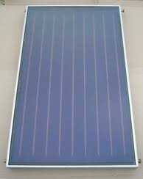
Fig: 2.7.1 Solar cell/ plate
The opaque materials in the form of non-water based pigments, or...
it may be utilized by exposing the plate through a transparent film with
artwork on it.
The film may be created by drawing on acetate, photocopying
or scanning and printing on film, or darkroom techniques with kodalith.
a positive transparency is for printing as an etching; a negative
transparency is for printing a relief impression. Photovoltaic (PV) cells utilize semiconductor technology to convert solar radiation directly into an electric current which can be used immediately or stored for future use. PV cells are often grouped in the form of “modules” to produce arrays which have the capability to produce power for orbiting satellites and other spacecraft. Recently, with the continual decline of manufacturing costs (declining 3% to 5% per year in recent years), uses of PV technology have grown to include home power generation, and grid-connected electricity generation. Installations of PV systems have also been increasing due in large part to comprehensive incentive programs which help reduce the costs of these systems and also allow users to sell excess electricity back to the public grid (feed-in).
Solar panels generate electricity using the same principles of electronics as chemical batteries or standard electrical outlets. With solar panels, it's all about the free flow of electrons through a circuit.
Evacuated heat pipe tubes are designed such that convection and heat loss are eliminated, where as Flat-plate solar panels contain an air gap between absorber and cover plate which allows heat loss to occur. Further, thermal heat pipe systems are capable of limiting the maximum working temperature, where as Flat-plate systems have no internal method of limiting heat buildup which can cause system failure. Finally, evacuated heat pipe systems are lightweight, easy to install and require minimal maintenance. Flat-plate systems, on the other hand, are difficult to install and maintain, and must be completely replaced should one part of the system stop working.
To understand how solar panels generate electrical power, it might help to take a quick trip back to high school chemistry class. The basic element of solar panels is the same element that helped create the computer revolution -- pure silicon. When silicon is stripped of all impurities, it makes a ideal neutral platform for the transmission of electrons. Silicon also has some atomic-level properties which make it even more attractive for the creation of solar panels.
- This cement helps to prevent the panel from becoming too hot, though solar energy panels can still overheat. Silicon solar energy panels are constructed differently than crystalline solar energy panels.
- While years of free energy and decreased dependence on fossil fuels may sound great, no examination of solar energy pros and cons is complete without a look at the price, which is considered the largest barrier to conversion to solar energy use. Solar energy panels and cells are very costly, and several may be required to power a home, business, or vehicle.
2.7.2 Advantages:
- Solar energy is free of pollution.
- The plant requires little maintenance or help after setup.
- It is economical.
- When it is connected to the grid, solar energy can overtake the highest cost electricity at peak demand and can also reduce grid loading, apart from getting rid of the need for local battery power in darkness.
2.7.3 Disadvantages:
- It is available only by day and not when the sky is cloudy, thereby reducing the chances of it being totally reliable and requiring storage facilities.
- It needs a backup power plant to be kept hot and to replace solar power stations as they stop producing energy.
- Keeping backup plants hot includes an energy cost which includes coal burning.
- Places located at high altitudes or those that are often cloudy are not targets for solar power use.
- It can only be used to power transport vehicles by converting energy into another form of energy and recurring an energy penalty.
- Solar cell technologies produce DC power which needs to be converted to AC power, incurring an energy penalty.
Solar energy can be used to generate electricity using photovoltaic solar cells and concentrated solar power, apart from other means. You can use solar power in the house for domestic use.
2.7.4 Applications of solar technology:
Average insulation showing land area (small black dots) required to replace the world primary energy supply with solar electricity. 18 TW is 568 Exajoule (EJ) per year. Insulation for most people is from 150 to 300 W/m² or 3.5 to 7.0 kWh/m²/day.
Solar energy refers primarily to the use of solar radiation for practical ends. However, all renewable energies, other than geothermal and tidal, derive their energy from the sun.
Solar technologies are broadly characterized as either passive or active depending on the way they capture, convert and distribute sunlight. Active solar techniques use photovoltaic panels, pumps, and fans to convert sunlight into useful outputs. Passive solar techniques include selecting materials with favorable thermal properties, designing spaces that naturally circulate air, and referencing the position of a building to the Sun. Active solar technologies increase the supply of energy and are considered supply side technologies, while passive solar technologies reduce the need for alternate resources and are generally considered demand side technologies
Solar cells can also be applied to other electronics devices to make it self-power sustainable in the sun. There are solar cell phone chargers, solar bike light and solar camping lanterns that people can adopt for daily use.
Solar power plants can face high installation costs, although this has been decreasing due to the learning curve. Developing countries have started to build solar power plants, replacing other sources of energy generation.
2.8 Wind Turbine:
A wind turbine is a device that converts kinetic energy from the wind, also called wind energy, into mechanical energy; a process known as wind power. If the mechanical energy is used to produce electricity, the device may be called a wind turbine or wind power plant. If the mechanical energy is used to drive machinery, such as for grinding grain or pumping water, the device is called a windmill or wind pump. Similarly, it may be referred to as a wind charger when used for charging batteries.
The result of over a millennium of windmill development and modern engineering, today's wind turbines are manufactured in a wide range of vertical and horizontal axis types. The smallest turbines are used for applications such as battery charging or auxiliary power on boats; while large grid-connected arrays of turbines are becoming an increasingly important source of wind power-produced commercial electricity.
Types:

Horizontal axis
Horizontal-axis wind turbines (HAWT) have the main rotor shaft and electrical generator at the top of a tower, and must be pointed into the wind. Small turbines are pointed by a simple wind vane, while large turbines generally use a wind sensor coupled with a servo motor. Most have a gearbox, which turns the slow rotation of the blades into a quicker rotation that is more suitable to drive an electrical generator.
Since a tower produces turbulence behind it, the turbine is usually positioned upwind of its supporting tower. Turbine blades are made stiff to prevent the blades from being pushed into the tower by high winds. Additionally, the blades are placed a considerable distance in front of the tower and are sometimes tilted forward into the wind a small amount.
Downwind machines have been built, despite the problem of turbulence (mast wake), because they don't need an additional mechanism for keeping them in line with the wind, and because in high winds the blades can be allowed to bend which reduces their swept area and thus their wind resistance. Since cyclical (that is repetitive) turbulence may lead to fatigue failures, most HAWTs are of upwind design.
Turbines used in wind farms for commercial production of electric power are usually three-bladed and pointed into the wind by computer-controlled motors. These have high tip speeds of over 320 km/h (200 mph), high efficiency, and low torque ripple, which contribute to good reliability. The blades are usually colored white for daytime visibility by aircraft and range in length from 20 to 40 metres (66 to 130 ft) or more. The tubular steel towers range from 60 to 90 metres (200 to 300 ft) tall. The blades rotate at 10 to 22 revolutions per minute. At 22 rotations per minute the tip speed exceeds 90 metres per second (300 ft/s). A gear box is commonly used for stepping up the speed of the generator, although designs may also use direct drive of an annular generator. Some models operate at constant speed, but more energy can be collected by variable-speed turbines which use a solid-state power converter to interface to the transmission system. All turbines are equipped with protective features to avoid damage at high wind speeds, by feathering the blades into the wind which ceases their rotation, supplemented by brakes.
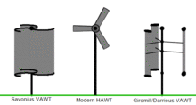

Vertical axis design
Vertical-axis wind turbines (or VAWTs) have the main rotor shaft arranged vertically. Key advantages of this arrangement are that the turbine does not need to be pointed into the wind to be effective. This is an advantage on sites where the wind direction is highly variable, for example when integrated into buildings. The key disadvantages include the low rotational speed with the consequential higher torque and hence higher cost of the drive train, the inherently lower power coefficient, the 360 degree rotation of the aerofoil within the wind flow during each cycle and hence the highly dynamic loading on the blade, the pulsating torque generated by some rotor designs on the drive train, and the difficulty of modelling the wind flow accurately and hence the challenges of analysing and designing the rotor prior to fabricating a prototype.
With a vertical axis, the generator and gearbox can be placed near the ground, using a direct drive from the rotor assembly to the ground-based gearbox, hence improving accessibility for maintenance.
When a turbine is mounted on a rooftop, the building generally redirects wind over the roof and this can double the wind speed at the turbine. If the height of the rooftop mounted turbine tower is approximately 50% of the building height, this is near the optimum for maximum wind energy and minimum wind turbulence. It should be borne in mind that wind speeds within the built environment are generally much lower than at exposed rural sites, noise may be a concern and an existing structure may not adequately resist the additional stress.
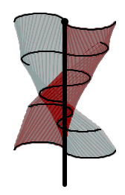
CHAPTER 3: PROJECT DESCRIPTION
In this chapter, schematic diagram and interfacing of components to inverter, DC motor, battery, motor, solar are considered
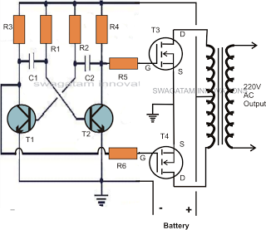
Fig 3.1: schematic diagram of Hybrid Energy (Wind-Solar) for Rural Electrification
INVERTER CIRCUIT EXPLANATION:
I have already discussed one 50 watt inverter circuit in one of my earlier posts, the only difference between the previous and the present design is in the output stage. The previous circuit involved power transistors where as here we have utilized mosfets making the configuration much easier and straightforward.
Rest of the stages are pretty much the same, in the earlier circuit we saw the involvement of a transistor based astable multivibrator for the generation of the required 50 Hz oscillations, here too we have incorporated a transistor operated AMV.
The earlier circuit had a couple of 2N3055 transistors at the output and as we all know driving power transistors efficiently requires proportionate amount of base drive, relative to the load current, because transistors depend on current drive rather than voltage drive, in contrast to mosfets.
Meaning, as the proposed load becomes higher, the base resistance of the relevant output transistor also gets dimensioned accordingly for enabling optimal amount of current to the base of the transistors,
Due to this obligation, in the previous design a additional driver stage had to be incorporated for facilitating better drive current to the 2N3055 transistors.
However when it comes to mosfets, this necessity becomes completely insignificant. As can be seen in the given diagram, the AMV stage is instantly preceded by the relevant gates of the mosfets, because mosfets have very high input resistance, which means the AMV transistors wouldn't be unnecessarily loaded and therefore the frequency from the AMVwouldn't be distorted due to the integration of the power devices.
The mosfets are alternately switched, which in turn switches the battery voltage/current inside the secondary winding of the transformer.
The output of the transformer gets saturated delivering the expected 220V to the connected loads.
PartsList
R1,R2=27K,
R3,R4,R5,R6=470Ohms,
C1,C2=0.47uF/100Vmetallized
T1,T2=BC547,
T3,T4=any30V,10ampmosfet,N-channel.
Transformer=9-0-9V,8amp
Battery = 12V,10AH

CHAPTER 4: ADVANTAGES AND DISADVANTAGES

Advantages:
- This system helps in wind energy generation.
- Storing of Solar energy
- Efficient and low cost design.
- Low power consumption.
- Easy to operate.

Disadvantages:
- This system requires periodic monitoring and maintenance.
- This system fails to work if the load is heavy.
- Status of operated devices is not known.

Applications:
  - In industries, streets, etc which can be practically implemented in real time.
  - Agricultural applications, water pump control, fencing control, street light control.
  - Houses etc.,

CHAPTER 5: RESULTS

5.1 Result:

The project “Hybrid Energy (Wind-Solar) for Rural Electrification” was designed such that to deliver power to switch on the loads like water pump. The dynamo uses electromagnetic principles to convert mechanical rotation into direct current (DC) using wind energy. The system generates electrical power as non-conventional method by wind energy power using wind turbine set up. We also use solar energy and hydel energy to charge the battery.
5.2 Conclusion:
Integrating features of all the hardware components used have been developed in it. Presence of every module has been reasoned out and placed carefully, thus contributing to the best working of the unit. Secondly, using highly advanced IC’s with the help of growing technology, the project has been successfully implemented. Thus the project has been successfully designed and tested.
5.3 Future Scope:
Our project “Hybrid Energy (Wind-Solar) for Rural Electrification” is mainly intended to design a wind based energy generation system for emergency head lamp applications.
The entire system involves three types of power generations solar, wind based power generation systems. The battery which is used can be recharged with the two generation inputs like solar and wind turbine. From this energy the water pump can be controlled using inverter design. The battery is connected to the inverter. This inverter is used to convert the 12volt DC to the 230 Volt AC. This 230 volt AC voltage is used to activate the loads like water pump.

REFERENCES

The sites which were used while doing this project:
1. www.wikipedia.com
2. www.electronicforu.com
3. www.allaboutcircuits.com

Books referred:
- Electronics for You- Garrett - OKM - Minelab Authorised
- Basic Skills: Electronics by Tom Duncan
- Electronics-A First Course by Owen Bishop

